
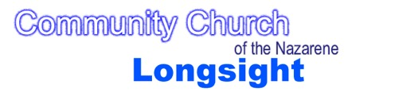


Important Contact

Information

DSL@longsightnazarene.org.

Thirty one: eight
tel: 03030031111

POLICY AND PROCEDURES FOR SAFEGUARDING THE WELFARE OF CHILDREN AND

YOUNG PEOPLE
Lead Designated Contact for the Church for Child Protection Issues

Jennifer Mackay
2nd Designated Contact for the Church for Child Protection Issues
Revd Carl McCann

As members of Community Church of the Nazarene, Longsight, we recognise that our work with children and young people is the responsibility of the whole organisation and we commit ourselves to their nurture and protection. It is the responsibility of each of us to ensure that our children and young people are not abused in any way.

This church accepts its responsibility to support, listen to, and work for healing with survivors, offenders, communities, and those who care about them. It takes seriously the issues of promotion of welfare so that each of us can reach our full potential in God’s grace.

This church is committed to supporting, resourcing, and training those who work with children and young people, and to provide supervision. Each worker with children and young people will know and undertake the relevant training and adhere to the recommendations of the church's policy and procedures for safeguarding the welfare of children and young people

We commit ourselves to co-operate fully with the appropriate Statutory Authorities when they are conducting an investigation into the abuse of children or young people.
District Superintendent BISD Church of the Nazarene

Social Services and Manchester Safeguarding Board (LADO)
Child Protection Referrals (Manchester City Council)

0161 234 5001

Suzannah
Sammons

Policy statement on Safeguarding the welfare of children and young people in the church

COMMUNITY CHURCH OF THE NAZARENE

LONGSIGHT
Updated August 2026

- Physical abuse - where a child's or young person's body is hurt or injured

- Emotional abuse - when a child or young person is harmed by a constant lack of love and affection, or by threats and taunting

- Sexual abuse - when adults, young people or other children use children or young people to satisfy their sexual desires

- Neglect and acts of omission - where adults fail to care for children or young people to the extent that their health and development is impaired.

All workers will have to complete Level 1 safeguarding training and a DBS form.

*Where a child witnesses domestic abuse, including hearing it from another room, this is a safeguarding issue. When managing cases of domestic abuse, the welfare of children must be paramount.

HERE WE
- Focus on God
- Love each other deeply
- Are a welcoming community – especially to the marginalised
- Endeavour to join with the Mission of God – in Longsight and wherever we live

The children and young people associated with our church form a valuable but vulnerable part of the fellowship. We have been given a responsibility to welcome them (Luke 9 v 48), to allow them unhindered access to Jesus (Mark 10 v 13 - 16), and to protect them (Matthew 18 v 6 - 10).

The Home Office has published a set of guidelines that provide a framework to promote child welfare and prevent abuse. ‘Working Together to Safeguard children’ (2023), underpinned by the ‘Children Act’ (2004), and subsequent documents which outline the procedures that are recommended to safeguard those under 18. We, as a church and as individuals, hold a position of trust in the community for the welfare of the children and young people that we meet and work with. Thirty one: eight and the NSPCC provide information with regards to legislation and changes in polices for faith groups.

https://learning.nspcc.org.uk/safeguarding-child-protection

This document is intended to provide guidance on how to follow the Home Office guidelines and understand our safeguarding responsibilities.
- To protect children and young people from abuse.
- To help workers to act in a responsible way if abuse is disclosed or discovered
- To prevent situations arising where workers could be falsely accused of abuse.
- To ensure workers/volunteers and supported in order to create safer working practices in accordance with safer recruitment and training.

There are many different forms of abuse and ways to define it. For simplicity it can be considered under four categories:

INTRODUCTION AND STATEMENT

Table of Procedural Contents.

Page 4 Procedures for Keeping CYP safe

Page 6 Supporting Paid Employees and Volunteers.

Page 8 Safer Recruitment.

Page 9 Action if abuse is suspected.

Page 11 Flowchart for Action if abuse is suspected.

Page 12 What will happen next if abuse is suspected.

Page 13 Responsibilities

Page 13 Training

Page 14 Use of Digital Media

Page 15 Role of the DSL

Page 16 Sample Worker/Volunteer Form

Page 18 Sample Reference Request Form

Page 19 Sample Reference Reply Form

Page 20 Sample Child Protection Checklist

Page 21 Sample General Consent and Medical Form

Page 23 Sample Registration Form

Page 25 Sample Incident Form

Page 26 Sample Risk Assessment

Page 27 Sample Incident Form

e) The following are recommended MINIMUM numbers of leaders to children:

0 - 2 years of age 1 leader (over 18yrs old) to every 3 children

2 - 3 years of age 1 leader (over 18yrs old) to every 4 children

3 - 8 years of age 1 leader (over 18yrs old) to every 8 children

Over 8's 1 leader (over 18 yrs old) for the first 8 children and 1 for every 12 subsequent children.

For example for a group of children aged over 8:

If you have 20 or fewer children or young people you should have 2 leaders.

If you have 21 to 32 children or young people you should have at least 3 leaders

If you have 33 to 44 children or young people you should have at least 4 leaders etc.
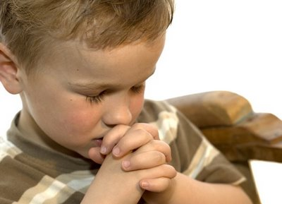
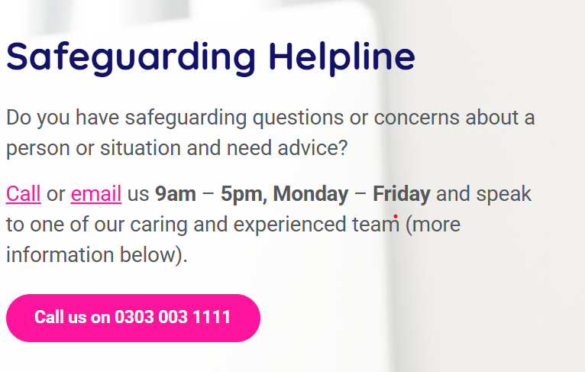
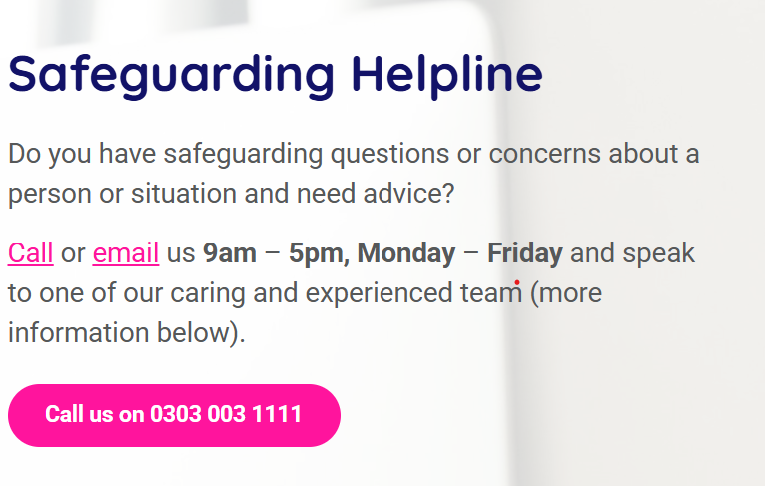

If possible, a worker should not be on their own with a child or young person in a location where they cannot be seen by other people. This may mean working in rooms with the doors left open. If counselling a child or young person and privacy and confidentiality are necessary, ensure that another adult knows where the worker is and with whom. The child or young person must also be told where other adults are.

A child or young person should not be invited to a worker’s home alone. If a worker meets a young person on their own it should not be in private, but in a public place (e.g. McDonald’s). Ensure that the parents know where the child or young person is and have given their consent for the meeting.

Never leave children or young people unsupervised in a room.

Keep a register of the children and young people with addresses, emergency contact numbers and any relevant health information (asthma, allergies, fits, etc). These should be stored securely in the Pastor’s cupboard or on-line.

Adopt a policy statement on safeguarding the welfare of children and young people

A statement is included in this policy. It should be agreed by the Church Board and recommended to a general church meeting and adopted. The statement should be reviewed annually. Each worker and leader should have a copy of the statement.

Plan the work of the church to minimise situations where abuse may occur.

The work of the church in every department should be planned so as to minimise situations where abuse of children or young people may occur. Some of the obvious things are listed but this is a starting point not a complete list.

Area 1. Procedural Guidance for the Safeguarding of Children and Young People.
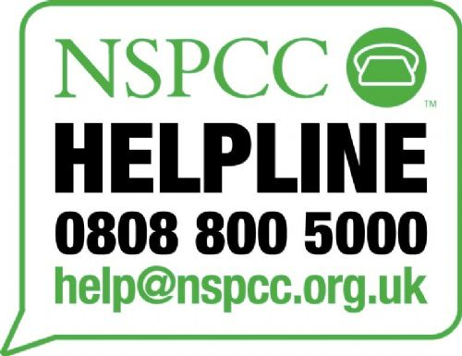
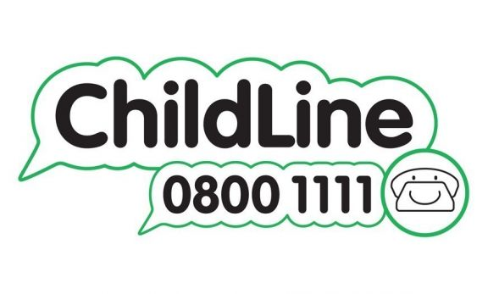




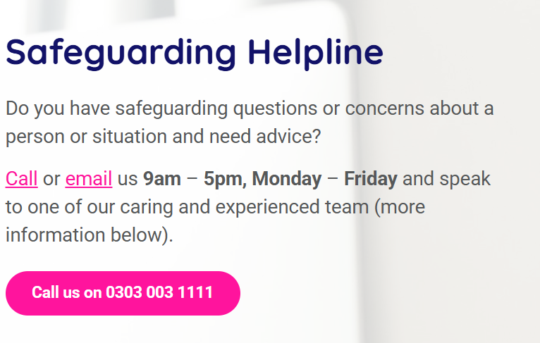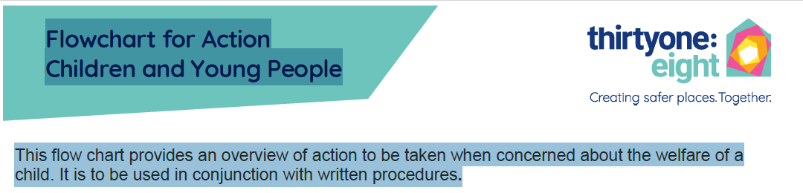

In addition to this, where the activity is out of view of the parent/guardian (a person with legal parental responsibility), if possible, never have less than 2 leaders in the Star Hall if the group is mixed try and have one male and one female leader.

If there are not enough approved leaders to run the group within the guidelines, or where a worker may feel compromised, the lead worker may choose to amend the activity or cancel the group making any appropriate arrangements (e.g. Notifying parents/guardians).

If taking children or young people on a trip for any reason make sure that parents or guardian are aware and have given written permission. This can be done by sending a note that requires a parental signature of permission for the trip and gives permission for you to obtain medical help if required. Ensure that the church has adequate insurance cover for the trip and any planned activities.

If camping or away overnight make sure that separate washing and toilet facilities are provided for male and female, that dormitories are single sex and that there is no sharing of sleeping bags or beds. A worker should avoid sharing a room with only one or two children or young people. If it is unavoidable then written consent should be given by the parents or guardian.

Examples of good practice
- Treat all children and young people with respect and dignity befitting their age
- Watch language, tone of voice and where you put your body
- Not invade the privacy of children or young people when they are showering or toileting
- Not engage in rough physical or sexually provocative games or activities
- Not make suggestive comments about, or to, children or young people even in 'fun'
- Avoid inappropriate or intrusive touching of any kind
- Avoid scape-goating or ridiculing any child or young person
- Learn to control and discipline without physical punishment
- Make sure another adult is present if, for example, a child has soiled their underclothes and needs to be thoroughly washed.
- Follow these guidelines when in contact with the children and youth when NOT at the church.

Every worker should know where the nearest telephone is in case of an emergency and parents, if possible, should have the lead worker’s phone number.

No adult should be alone with a child or young person in a car or minibus unless there is no safe alternative, in which case the parent or guardian must give consent. Seatbelts must be worn and no more passengers carried than there are proper seats (including car seats where legally required). Vehicles used for church work must be fully insured and driven with due care by experienced drivers who hold a current, legal, driving license and business insurance.

Ensure that children form relationships with more than one member of the team, to ensure that they have a choice of adults to talk to

Children should be encouraged to get to know more than one member of the team so that they have a choice of adults to talk to. If a child or young person comes to an adult to talk about a sensitive issue, the adult should ask them who they want to talk to. The adult should discuss with their group leader about who would be the best person to talk to the child or young person and follow this up with the consent of the child (and their parent/guardian if appropriate).

Apply the same standard procedures to all leaders and workers

Remember, anyone can be a potential abuser. Applying the same rules to everyone who works with children or young people gives everyone the same protection. In the event of an accusation, paid workers or employees will be suspended or have an absence leave, and volunteers will be suspended in their role until the accusation has been investigated.

Give all workers a clear role

Abuse can be more easily concealed or go unnoticed if there is confusion over responsibilities and duties. Each worker should discuss with their group leader what their role is. It should be clear what they are expected to do and to whom they are accountable. The worker should fill in “Workers/Volunteers Form and complete a DBS Form and Safeguarding Level 1 Training. One copy will be retained by the worker and one by the church. Forms to be reviewed annually by the DBS coordinator.

Use supervision as a means of protecting children and young people

Supervise and train. Workers will not just be left to 'get on with it'. All workers will be given this safeguarding welcome pack outlining the work and policies of the church in their annual Safeguarding Training. The paid workers and volunteers, should meet at regular intervals with leaders to discuss and plan work and the children and young people. Pastoral team members should make the time at regular intervals to 'drop in' and watch how things are going in groups and sessions etc. Particular attention should be paid to any children or young people who are apparently either harshly treated or highly favoured as this may be indicative of abuse.

Area Two: Support the paid workers and volunteers

The way that the church supports its workers will help to protect the children and young people.

AREA THREE: Safer Recruitment

In the past, many areas of children's and young people's work may have been so short staffed that a new volunteer to help would have been accepted almost without question. There may even have been a definite reluctance to ask questions in case it 'put the new worker off'.

Alternatively, the church leadership may have known the people involved so well that it was felt unnecessary or even slightly offensive to put them through any form of selection procedure. However we have a duty to prevent unsuitable people from working with our children and young people and a selection procedure will help to achieve this.

Treat all would-be workers as job applicants

Everyone over the age of 16 (where possible) wishing to work with children or young people should be asked to complete a “Workers/Volunteers Form This could also be done initially by all existing workers.

Where possible, gain at least one two reference for each helper over the age of 16.

Referees should have first-hand knowledge of the applicant's previous work with children or young people. Any vague or ambiguous replies should be followed up. It is important to ask about a person’s character particularly if they have no previous experience of working with children or young people. If there are doubts expressed then the applicant's offer to work should be channeled into other areas of Church work. Confidentiality is important. A referee may state that a person is unsuitable to work with children or young people but be unwilling to disclose the details. Please see “Reference Request page 18” and “Reference Reply page 19”.

Explore the applicant's experience of contact or working with children or young people in an informal interview or conversation.

One or two experienced workers nominated by the Children and Youth Work sub-group should have an extended conversation with the applicant about any previous work with children or young people. The conversation should cover training needs, the applicant's willingness to be trained, and the church policy on Child Safety.

Obtain a DBS Enhanced Disclosure for all workers and volunteers aged over 16 who are involved with children and young people (refer to DBS regulations on ‘regulated activity’).

Children's work is exempt from the provisions of the Rehabilitation of Offenders Act 1974. All convictions, however old, which relate to children/young people must be disclosed and considered by the group leader.

Until the DBS Enhanced Disclosure has been obtained a worker or volunteer should not be left in sole charge of a group of children or young people. If a volunteer has moved from another church or organisation where they have worked with children or young people, it is advisable to find out why. All DBS forms are processed by thirtyone:eight.

Appointments should be made conditional subject to a satisfactory 6-month probation period.

During this period the new worker should talk regularly with their group leader (or a nominated person), receive training and be observed working with children and/or young people. At the end of the period the worker should talk with the person to whom they are responsible to review their performance and confirm or terminate the appointment.
Further guidance at: https://thirtyoneeight.org/dbs-service/

If the alleged abuser is a member of staff or a volunteer?

If the alleged abuser is a member of staff the group leader should follow the above procedure. The Designated Safeguarding Person should report it to Manchester Council Local Authority Designated Officer (LADO) within one working day.

Manchester Council Local Authority Designated Officer – LADO (LADO) Tel: 0161 2345001

Thirty one@eight tel:03030031111

- If the alleged abuser is a member or staff or a volunteer currently involved in activities run through Community Church of the Nazarene, Longsight they will be informed of the allegation made against them by the group leader or the designated contact.
- Until the investigation has been completed, the volunteer or staff member will be on leave.
- The Community Church of the Nazarene, Longsight would seek to support the person against whom the allegation has been made as appropriate.
- The Community Church of the Nazarene, Longsight would seek to support the child and family as appropriate.

If you suspect abuse – move upwards

- Do not delay
- Do not act alone - consult whoever you are responsible to, or another appropriate person
- Do not start to investigate
- Contact your group leader or your Designated Contact Tel no: As above
- If the child is in immediate danger contact the police. Tel no: 999 (or 101 non-emergency)
- Through consultation with the designated contact a referral may be made to Social Services.

What should the group leader do next?

The group leader will contact the Designated Safeguarding Person as soon as reasonably possible or the relevant statutory services or follow the flowchart below.

Area 4: GUIDELINES FOR PROCEDURES IF ABUSE IS DISCLOSED OR DISCOVERED

APPENDIX THREE continued…

If the alleged abuser is a member of staff or a volunteer?

If the alleged abuser is a member of staff the group leader should follow the above procedure. The Designated Safeguarding Person should report it to Manchester Council Local Authority Designated Officer (LADO) within one working day. In the event of an accusation against a volunteer or paid member of staff, employees will be suspended or have a leave of absence until the accusation has been investigated.

Manchester Council Local Authority Designated Officer – LADO (LADO) Tel: 0161 2345001

Thirty one@eight tel:03030031111

- If the alleged abuser is a member or staff or a volunteer currently involved in activities run through Community Church of the Nazarene, Longsight Church Board Executive will be informed of the allegation made against them by the group leader or the designated contact.
- If the allegation is referred to the LADO The Church will take their guidance as to how to proceed, including whether the volunteer can continue in their role during the investigation.
- The Community Church of the Nazarene, Longsight would seek to support the person against whom the allegation has been made as appropriate.
- The Community Church of the Nazarene, Longsight would seek to support the child and family as appropriate.

If a child or young person wishes to talk about abuse

- Do NOT push for information or ask leading questions e.g. 'It was X wasn't it?'
- Make notes as soon as possible about what was said to you, with dates and times, and sign and date it.
- Do NOT promise confidentiality. Tell the child or young person that you may have to tell someone else.
- Accept what the child or young person says, keeping calm and looking at them directly
- Tell the child or young person they are not to blame
- Be aware the child or young person may have been threatened
- Reassure the child or young person that they have done the right thing to tell you and that you believe them
- Let them know what you are going to do next and what will happen next (i.e. “I am going to talk to X (the Designated Safeguarding Person) about this as soon as possible”.

What should the group leader do next?

The group leader will contact the Designated Safeguarding Person as soon as reasonably possible or the relevant statutory services. All allegations need to be logged and sent to the DSL on the DSL email address. An example of how to log a disclosure can be found at the back.

DSL@longsightnazarene.org.

GUIDELINES FOR PROCEDURES IF ABUSE IS DISCLOSED OR DISCOVERED

APPENDIX THREE continued…
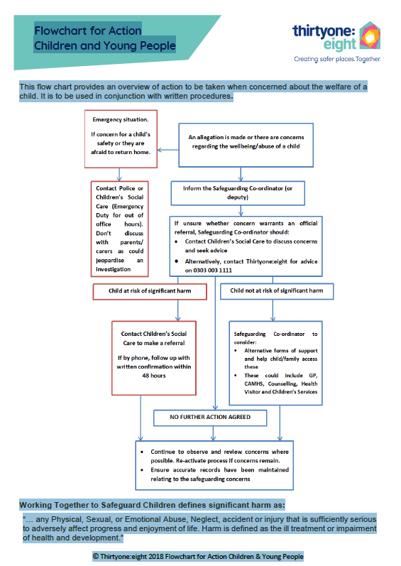

What will happen next?

- The Designated Safeguarding Person(s) will seek professional involvement by making a referral to Social Services or similar organisiation or by taking advice from thirtyone:eight. All referrals or concerns should be logged and sent to the DSL, who will advise and suggest the next course of action.

- The Designated Safeguarding Person(s) should inform the Church Board or the paid team with as much detail as appropriate, keeping confidentiality. If the allegation is against a member of the team, the church Board will be informed and the District Superintendent.

The process of professional involvement might usually follow this course:

- A strategy meeting with Social Services, the person suspecting abuse, possibly the Police Child Protection Team and other professionals

If the alleged abuser is a member of staff or a volunteer the LADO will be involved in overseeing the progress of the allegation with the police and Social Services. (Manchester City Council

Local Authority Designated Officer) Tel: 0161 2345001 or thiryone:eight tel:03030031111
- Social Services will make a decision as to whether an investigation is warranted

- Such an investigation will conducted by the relevant service(s) and may include

An informal talk with the child or young person

A formal videotaped interview

Medical examination

Preliminary Family Assessment

- If there is sufficient concern a Child Protection Conference will be set up to decide the best course of action to protect the child and help the family

As we get to know the children and young people in our care we learn about their families, their homes and their backgrounds. We may hear about situations or events that cause us concern, even if they would not be classed as “abusive”.

A worker should discuss these situations or events with their group leader, who should then decide upon appropriate action.

HOWEVER, there are some situations which, although not necessarily abusive, should be brought to the attention of the statutory services.

Children or young people who are privately fostered.

For example, if a member of staff becomes aware that a child or young person is being privately fostered (ie is living with a different family but not arranged through social services) they should tell their team leader.

The team leader should check the facts of the situation (not investigate) and inform the designated contact, who should then take appropriate action: this may involve talking to the parents or families involved. Manchester City Council Child Protection services MUST BE AWARE OF THE SITUATION.

When working with children and young people, the following best practice is recommended (based on the NSPCC guidance, September 2023).

Under 2 1:3

2-3 years 1:4

4-8 years 1:6

9-12 years 1:8

13-18 years 1:10

AREA SIX: TRAINING

It is not enough to give workers guidelines without the necessary skills to carry them out. Training and mentoring will be coordinated by the pastoral team and church board, in line with the recommendations from the safeguarding team. Training in the prevention of abuse and the actions to take if abuse occurs should be included as part of the workers training and induction process.

AREA FIVE: Take seriously our responsibilities towards the children and young people in our care

It is not enough to give workers guidelines without equipping them with the skills to carry them out. Training in the prevention of abuse and the actions to take if abuse occurs should be included as part of all workers' training. A worker's willingness to receive training should be investigated during their initial interview. Specific training needs should be considered at an annual review of a worker's role with the group. The training required is subject to the DSL’s requirements and should be coordinated by a member of the Pastoral Team, the DSL team or the church board.

Social media

Workers should not use chat room, messenger services or share any personal information with children or young people on any social media platform. Photographs should not be taken on the workers phones without permission from a parent/carer. Social media platforms (unless for parents/carers) should not be used to communicate with young people.

Contacting children and young people by phone, text or email should never be undertaken without parental/guardian knowledge or consent.

Mobile Phones

Workers should not give out their personal/private numbers/email address to young people for any reason unless approved specifically by a parent or guardian. If texting use group texts whenever possible. Communication should be limited to the exchange of information about programs or events only.

The use of phones for photography and video are subject to the policy on the use of photography and digital images. Parental consent is required. However, it is not considered good practice for workers to use mobile phones for this purpose. It leads workers open to accusation.

If you require, additional information, please refer to thirtyone: eight for additional information.

AREA SEVEN: Use of digital media

Internet/Email

Workers should not be emailing children or young people directly as individuals but may do so a part of a group list (having received permission). Again, communication should be limited to information in relation to sessions or events. Group emails should also give individuals the opportunity to have their contact details removed from the list by including a statement such as: “if you wish to be removed from this email list please reply”. All workers must keep a copy of emails sent. Workers will be held accountable for these forms of communication. Use of work email is encouraged.

Receiving bullying/threatening or inappropriate texts of emails

Workers should not delete these. They should record the incidents, inform their line manager, and/or the Designated Safeguarding Person.

Workers need to be aware of their responsibilities to protect themselves, the young people they work with and the organisation. Individuals are deemed responsible for any material that appears online or is sent by digital media. E.g, inappropriate postings on social media platforms (even if someone else does it!). Any breach of these could result in a worker being asked to step down from their role as a volunteer or paid employee.

Please refer to more detailed guidelines please contact thirtyone:eight.

ONE

The Lead Designated Safeguarding Person is Suzannah Sammons

From May 26th 2022

Reviewed July 2026

The Lead Designated Safeguarding Person(s) will be a person who is registered Recruiter with the Churches Agency for Safeguarding (CAS) to oversee (not necessarily administer) DBS Disclosures on behalf of the church and will work with the other Designated Safeguarding Person(s) appointed by the church. www.churchsafe.org.uk It is recommended a member of the ministry team be part of the DBS application process.

The Church appoints .. Suzannah Sammons (Lead)

.. Jennifer Mackay (2nd Lead)

Rev Lynn Birkinshaw (Team Leader)

DBS Admin support – Rev Steve Birkinshaw and Rev Nicole McConkey

As Designated Safeguarding Person(s) for the church and supports him/her/them in the role which is to:
- Be aware of and support in the administration and management of DBS Enhanced Disclosures as needed; this does not necessarily need to be done by the Safeguarding Lead.
- Provide support and advise the paid Pastoral Team, employees, and volunteers in fulfilling their roles in relation to safeguarding themselves, children and young people;
- Provide a point of reference to advise on safeguarding issues;
- participate in/attend relevant training or signpost others to help keep the church up-to-date of any changes in good practice or legislation; If possible attend the DSL safeguarding lead course from thirtyone:eight.
- promote safeguarding best practice and training within the local church with the support of the Church Board and the congregations;
- work with the Church Board to review the Child Protection Policy and procedures.
- provide a written report to the church AGM including notification of any safeguarding concerns raised since the last AGM.

ROLE OF THE DESIGNATED SAFEGUARDING PERSON(S)

APPENDIX TWO

APPENDIX THREE

APPENDIX THREE continued…

APPENDIX THREE continued…

APPENDIX THREE continued…
By completing this information you give consent to be contacted about your role in children’s and youth work at Community Church of the Nazarene, Longsight.
This form should be given to your group leader, or to a Designated Safeguarding Person. Only your group leader and the Designated Safeguarding Person(s) will have access to this form, and they will treat the content confidentially.

WORKER/VOLUNTEER’S FORM

First name: | Surname:
Date of birth:

Address:

Email: | Phone number(s):
Emergency contact (name and phone number):

About yourself: Areas you would like to volunteer in…

Please mention any special interests you have (including sport, music, baking, drama, craft, games etc.)

Have you any qualifications, training or experience that you think could be useful?

(e.g. first aid, food preparation, minibus driving, running games, life saving, leading Bible studies…)

Please tell us something about yourself and what motivates you to volunteer for this role

APPENDIX FOUR
References
Please give details of two people who know you well enough to give you a personal reference who we can contact. They should both have known you for at least 2 years, and not be members of your family. One referee should NOT attend the Community Church of the Nazarene, Longsight.
Relationship to you:  Name:  Address:  Phone: | Relationship to you:  Name:  Address:  Phone:

Even more personally

For obvious and sensible reasons, regulations concerning those working with children and young people become stricter year by year. No matter how well we may know you, we need to have in writing various declarations from you.
Have you ever been convicted for a criminal offence, or aware of any action(s) or prosecution(s) pending against you, or currently being investigated?  YES / NO |  | Even if an answer on the left is ‘YES’, you may still be able to help at our clubs – please give further details on a separate sheet, or talk to your group leader to allow the matter to be considered further.

Have any church or other organisation ever considered or imposed restrictions on your involvement with young people?
YES / NO

Do you object to us making enquiries to verify the above answers? This will involve you to apply for a Disclosure certificate from the DBS.
YES / NO

I confirm that the information given above is correct and complete, and will advise you in writing of any changes which occur. I confirm that I will work with the children / youth team and respect the other leader’s decisions. My aim is to fulfill this role to the best of my ability and to keep the best interests of the children/young people at heart.

Signed Date

If you are under 18, please get your parent/guardian’s signature here.

I approve of my son / daughter / ward, as above, volunteering to help in the Children/Youth work.

Signed Date

APPENDIX FOUR continued…

WORKER/VOLUNTEER’S FORM continued…

Reference request letter

Please reply to:- ________________________________________ (insert the name of someone from the leadership team or a names person in this document)

Telephone:______________________

Dear

Re:

The person named above has volunteered to help at one of our Children’s or Youth groups and activities, and has suggested you as someone who could give a reference.

You will appreciate that before we can accept anyone to serve in young people’s work we must be satisfied that they are both suitable for and capable of performing the tasks required. We would therefore appreciate your opinion of this volunteer's qualities, skills, and experience with young people, and of their ability to work as part of a team.

Please also make any positive comments or express any reservations you may have on their capacity to work with children and youth.

Your comments will be valuable in helping us to assess both the persons’ suitability and the best way of using their abilities - for example, someone who is quite shy or tires easily is unlikely to mention those facts about themselves, but provided we know in advance we can avoid asking them to lead some of the more strenuous activities.

In making your comments please bear in mind that our children’s and youth clubs have a duty of care to protect children from harm of all sorts, whether of a physical, emotional or sexual nature. The information you share with us will be treated in the strictest confidence, and will not be seen by the volunteer.

Please use the enclosed form for your comments and return it as soon as possible in the pre-addressed envelope provided.

Thank you for taking the time to help us.

Yours sincerely,

APPENDIX FIVE (a)

REFERENCE REQUEST

Name of volunteer:

Name of person completing this form:

What is your relationship with the volunteer? e.g. Teacher /Church Minister / Relative / Friend / Employer etc

How long have you known the volunteer?

Is your contact more or less frequent than monthly?

How recent is your latest regular contact with them?

With your knowledge and experience of the volunteer, please comment on his/her suitability to work with children or young people. Please consider aspects such as character i.e. honesty, reliability, punctuality, initiative; personality and other qualities, health and stamina, gifts, abilities; and experience of working with children or young people.

Character qualities

Experience of working with children or young people

Are there any other comments you would like to make about the volunteer? (Continue over if necessary)

Any health related comments, which would affect their work with children or young people?

Any reservations you have, or any limitations we should bear in mind?

I offer the above comments on a PRIVATE AND CONFIDENTIAL basis, for use only by those organising the children and youth clubs. I understand that the information WILL NOT be seen by the volunteer.
Signed | Date
Address | Phone Number:

APPENDIX FIVE (b)

REFERENCE REPLY

This should be completed by the worker/volunteer and handed to the group leader or one of the Designated Safeguarding Team.

CHILD PROTECTION REQUIREMENTS CHECK-LIST

Name of volunteer/worker:

Name of group(s) working with (tick all that apply):

- Sunday School/creché  - Kids Club  Other(s): | - Youth Club  - NYI

Person(s) to whom responsible?

I have understood the nature of the work I am to do with children / young people. |  |  | - YES  - NO
I have read and understood the document titled Community Church of the Nazarene, Longsight Policy and Procedures For Safeguarding the Welfare of Children and Young People. |  |  | - YES  - NO
I understand that it is my duty to protect the children / young people with whom I come into contact. |  |  | - YES  - NO
I know what actions to take if abuse is discovered or disclosed. |  |  | - YES  - NO
I have completed the legally required application for a DBS check.  If NO, please note why: |  |  | - YES  - NO
I have completed the Longsight Community Church of the Nazarene “Workers’ Form” and handed it in to my group leader or one of the Designated Safeguarding Persons. |  |  | - YES  - NO
Signed (worker/volunteer): |  | Date:
Signed (Church/group leader): |  | Date:

APPENDIX SIX

GENERAL CONSENT & MEDICAL FORM

2) EMERGENCY DETAILS
I may be contacted by telephoning the following number(s):

Home (………....) ……………………………………. Mobile …………………….…………………….

Work (………....) …………………………………….

Name: …………………………………….…………………………………………………………………….

Relationship to child: …………………………………….…………………………………………………….

Address: …………………………………….…………………………………………………………….

……..…………………………………….………………………………………………………………………

1) DETAILS
I have read the attached letter and agree to my son/daughter/ward taking part in the activities organised by the COMMUNITY CHURCH OF THE NAZARENE LONGSIGHT [Insert name of group and details here. For example: Normal activities take place on Tuesday evenings (and occasional school holidays or weekends) and include: Indoor and outdoor team games e.g. ball games, relay races (this may include walking together to a local park); art and crafts; cooking; discussions; eating together. A separate consent form will be given for other trips.]

I acknowledge the need for good conduct and responsible behaviour on their part and that Community Church of the Nazarene Longsight reserves the right to prevent my child continuing with the activity in the case of poor behaviour. I am responsible for my child getting home safely from the church.

Name of group:
Usual time and day/evening of group:
Place (buildings) normal sessions takes place:
This consent form is to cover general activities and events detailed below and in the accompanying letter from [insert date] to [insert date]
This form is be completed in full by the parent/guardian and returned to the group leader.

APPENDIX SEVEN
4) DECLARATION BY PARENT/GUARDIAN (please tick the relevant boxes)
In the case of an emergency I agree to my child being given any medical, surgical or dental treatment, including general anesthetic and blood transfusion, as considered necessary by the medical authorities present.
I consent to my child taking part in the activities, and, declare my child to is able to participate in any activities mentioned.
I have noted that I am responsible for my child getting home safely from the group.
I will ensure that any change in the circumstances (e.g. recent medication or injury) which will affect my child’s participation will be notified to the Centre prior any activity
I consent to photographs and video to being taken for the sole use of Longsight Church of the Nazarene, and understand this will not be distributed to outside organisations.
Signature of Parent / Guardian …………………………………….…..…..… Date: …………………….
(Note. Parental consent is required for children aged 17 and under)

Name of parent / Guardian in block letters: ……….……………………………………………………….

3) MEDICAL INFORMATION

Does your child suffer from any medical conditions?
- YES ……………………………………………………………………………………………..…….
…………………………….…………………………………………………….……………………….
- NO
Does your child have any specific learning needs?
- YES ……………………………………………………………………………………………..…….
…………………………….…………………………………………………….……………………….
- NO
Is your child allergic or sensitive to any medication? (e.g. plasters, penicillin), insect bites or food?
- YES ……………………………………………………………………………………………..…….
…………………………….…………………………………………………….……………………….
- NO
Does your child have any special dietary needs? (e.g. vegetarian, religious)?

If yes, please provide details …………………………………………………………………..……..
Please state an alternative contact person in case we can’t reach you:

Phone number (………....) …………………………………….

Name: …………………………………….…….… Relationship to child: ………………………………….

Address: …………………………………….…………………………………………………………….

……..…………………………………….………………………………………………………………………

APPENDIX SEVEN continued…
Name of group:
Time and date of session:
Volunteers/workers present:
Others present:

Even if the group has an open door policy, a list of children/young people and volunteers/workers (even visitors) should be kept.

Consent forms (including contact details) should also be collected and kept securely but easy for workers to access in case of an emergency during the session.

REGISTER FOR USE WITH GROUPS

Name of child/  young person | Person(s) dropping child off | Person(s) picking child up | Notes (e.g. other arrangements for collection, accidents, etc.)

APPENDIX EIGHT
Session recording/reflection:
Name of child/  young person | Person(s) dropping child off | Person(s) collecting child | Notes (e.g. other arrangements for collection, accidents, etc.)

APPENDIX EIGHT continued…
What feedback have you received?

Have your concerns been followed up?

How and by what date will you follow up on your concerns?

Who have you spoken to about your concerns?

Child: YES / NO Name: Date:

Parent/guardian: YES / NO Name: Date:

Group leader YES / NO Name: Date:

Line manager: YES / NO Name: Date:

Other: YES / NO Name: Date:
Social services: YES / NO Name: Date:

Name of worker(s) or volunteer(s) completing this form:

Name of the group:

Name of the child/young person:

Date and time of incident:

Nature of concern:

Have you made a full written record of this incident/concern? Yes / No

This form should be used to keep a record of any incidents which occur, and which are reported to the group leader or one of the Designated Safeguarding Persons and given in person or through email.
As well as this report, you should make a full factual written record of your observations and any conversations, which should be signed and dated and stored in a suitable secure place (ideally a file within a locked filing cabinet in the office).

INCIDENT REPORT FORM (when relevant also complete an entry in the Accident Book)

APPENDIX NINE
Hazards/risks  Person(s) affected | What existing controls are in place? | Liklihood (L) | Severity (S) | Risk Rating  (LxS) | What additional controls needed?

For further guidance on how to complete a risk assessment speak to your line manager, or member of the pastoral team or church bard.
Signature of volunteer(s)/worker(s):

Date and time:

Signature of line manager or lead worker:

Date and time:

Risk Rating
1 – 2 = low priority
3 – 5 = medium priority
6 – 9 = high priority
Severity
1 = Low (minor cuts and bruises)
2 = Medium (serious injury or incapacitated for 3 days or more)
3 = High (fatality or a number of persons seriously injured)
Likelihood
1 = Low (seldom)
2 = Medium (frequently)
3 = High (certain or near certain)
Continue on another page if needed. Under additional controls you should note the additional measures that are needed to reduce the risk to an acceptable level and record who will do this and when additional controls have been implemented.

5

RISK DETAILS

Activity/activities being assessed?

4

2
Name of group:
Name of person carrying out assessment (print):

1

Date:
Review date:

3
Area/room/venue being assessed?

RISK ASSESSMENT FOR ACTIVITIES/MEETINGS

APPENDIX NINE continued…

APPENDIX TEN

Incident Reporting and Procedures Form

Name of worker(s) or volunteer(s) completing this form:

Name of the group:

Name of the child/young person:

Date and time of incident:
Nature of concern:

If you are concerned this is a matter of urgency, please contact the DSL lead, Second DSL. If these are not available and the accusation is not against a member of staff, please contact a member of the pastoral team or thirtyone:eight. Or contact the dsl team at….dsl@longsightnazarene.org
